

Project Name: E-Raktdaan-Blood bank Web application

Branch PG-DAC March-2022

Documentation On

**“E-RAKTDAAN-BLOOD BANK WEB APPLICATION”**

PG-DAC MARCH 2022

**Guided By: Moreshwar Pidadi**

Submitted By :

**Group No: 19**

* **Dipak Jadhav 220343020038**
* **Suhas Kajawe 220343020099**
* **Krishna Jade 220343020044**
* **Sumit Patil 220343020067**

**Table of Contents**

**1. Introduction 4**

1.1 Document Purpose **4**

1.2 Project Background **4**

1.3 Aim & Objectives **4**

**2. Business Requirements Overview**…………………………………………………………**5**

**3.Functional Requirements** **6**

3.1 Blood Bank Module **6**

3.2 Hospital Module **6**

3.3 Donor Module **6**

3.4Admin Module **6**

**4.** **Non-Functional Requirement………………………………………………………………7**

**5. Use Case Diagram 8**

5.1 Admin **9**

5.2 Student **10**

5.3 Teacher **11**

**6. Database Design 12**

1 Admin **12**

2 Bloodbank **12**

3 Bloodstock……………………………………………………………………………..…**13**

4 Donor **13**

5 Donorrequest **13**

6 Hospital **13**

7 Hospitalrequest **13**

8 Logintable **13**

9 Patient **14**

**7.**

**E-R Diagram...………………………………………………………………………………14**

**8. Snapshots………………………………………………………………………………….15**

**9. Conclusion 20**

**List of Figures**

**Use Case Diagrams 17**

Fig 1 Admin 8

Fig 2 Student 9

Fig 3 Teacher 10

Fig 4 ER Diagram 14

1. **Introduction:**

**1.1 Document Purpose:**

This document communicates the business requirements and scope for developing a web application for increasing blood bank accessibility. The scope of this document is to define the functional and non functional requirements, business rules and other constraints requirements.

## Project Background:

A. National Estimation of Blood Requirement in India report 2018(Ministry of health and family welfare government of India)

The study indicated that there should be 6.23% of the eligible population in a year to address the population need 3.43% of the eligible population should donate blood to address the clinical demand. The supply (the donations) was 3.19% of the eligible population. However, if the reported annual collection was considered as supply, the actual supplier 1,000 population was 2.62% per 1,000 eligible population which indicates a significant gap between demand and supply.

B. The clinical demand and supply of blood in India: A National level estimation study

The supply against demand was estimated at 92·6% for whole blood, 91·7% for red cells, 86% for plasma, 77·5% for platelets and 92·1% for cryoprecipitate. Similarly, the utilization against supply was reported at 98·7% for whole blood, 99·2%, 96·8% 97·6% and 94·6% for red cells, plasma, platelets and cryoprecipitate respectively.

Two reports mentioned above and the recent covid outbreak we faced shows the gap between demand and supply of whole blood and different components of the blood.

There is need of a platform to bridge this gap.

## 1.3 Aim & Objectives:

The aim of the project is to develop a web application to provide a platform for supply as well as demand side to fulfil the gap in demand and supply of the whole blood and the various components of blood.

Web application will provide an ease of access and reduce the hurdles between donors and to those who are in need of blood or blood components.

1. **Business Requirements Overview**

• E-Blood Bank System is the public web application.

• E-Blood Bank System will be opened to the India, but in the phase 1, the main target is in the Maharashtra State.

• There are mainly three types of user: Blood Bank, Hospital & Donor.

• Donors can search for the nearest blood bank for donating blood.

• Hospitals can search for blood, plasma and platelets available in the blood bank and even the information about the blood bank.

• E-Blood bank System provides the functions which connect the hospitals and the blood bank efficiently.

• E-Blood Bank System could be maintained by Administrator.

**3. Functional Requirements Overview**

E-Blood Bank system consists of four modules described as below.

1.Blood Bank Module

2.Hospital Module

3.Donor Module

4.Admin Module

**3.1 Blood Bank Module**

• Blood Bank can register and create new account.

• Blood Bank accepts request from Donor and book appointment.

• Blood Bank accepts request from Hospital regarding blood.

• Blood Bank shows stock of blood, plasma, platelets on web page.

• Blood Bank saves records of donor and hospital.

• Blood bank can be deleted and update account.

**3.2 Hospital Module**

• Hospital can register and create new account.

• Hospital can see stocks of blood bank.

• Hospital can select blood bank and raise request.

• Hospital can see history record.

• Hospital can delete and update the accounts.

• Hospital can add patient details in record for raising request.

**3.3 Donor Module**

• Donor can register and create new account.

• Donor can select blood bank.

• Donor can see stock of blood bank.

• Donor can raise request for blood donation

• Donor can delete and update accounts.

• Donor can select quantity of blood between range.

**3.4 Admin Module**

• E-Blood Bank should provide all function to admin how to handle the System.

• Authentication of authorise hospitals.

• Admin maintain donor history. (Maintain last date of blood donation).

• Admin will know all history of transaction.

• Admin can remove hospitals.

**4. Non-functional Requirements**

• The website should use professional design, look and feel and colour scheme.

• Users will have no limitations for accessing the application through Internet.

• Being a public website, the site must follow general usability guidelines for menus,

navigation, colours, links and other actions provided on the screens.

• The system should be designed in such a manner that user will be able to complete tasks in minimum number of steps.

## 5. Use-Case Diagram

**5.1 Admin:**

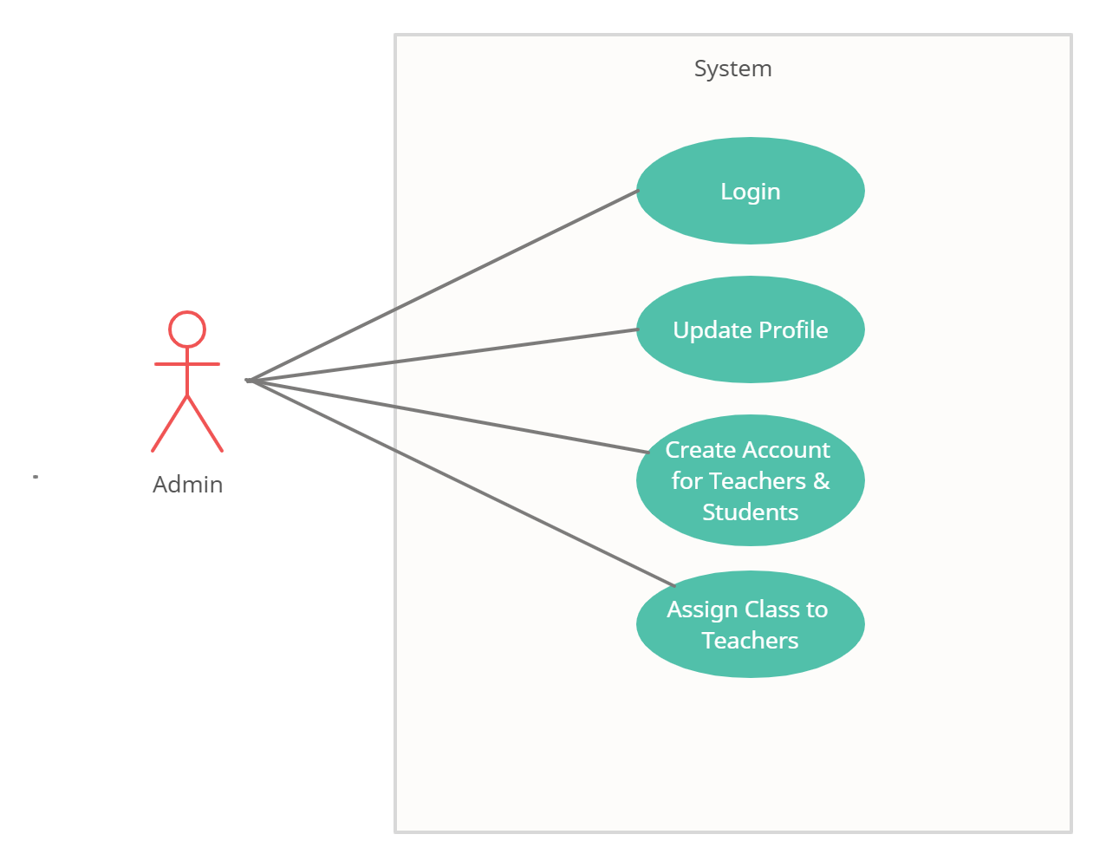

Fig. Use-Case Diagram for Admin

## 5.2 Student:

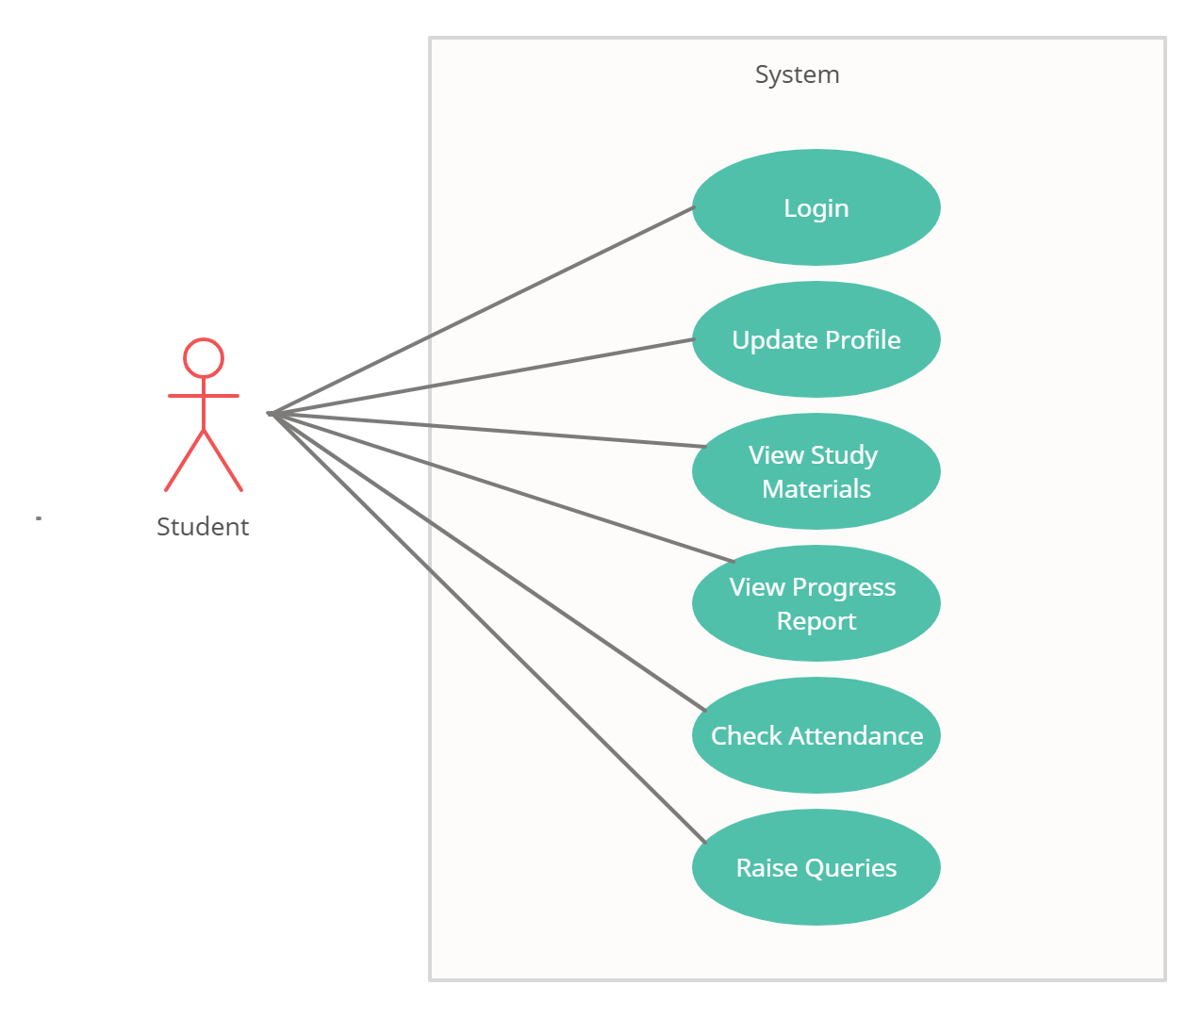

Fig. Use-Case Diagram for Student

**5.3 Teacher:**  
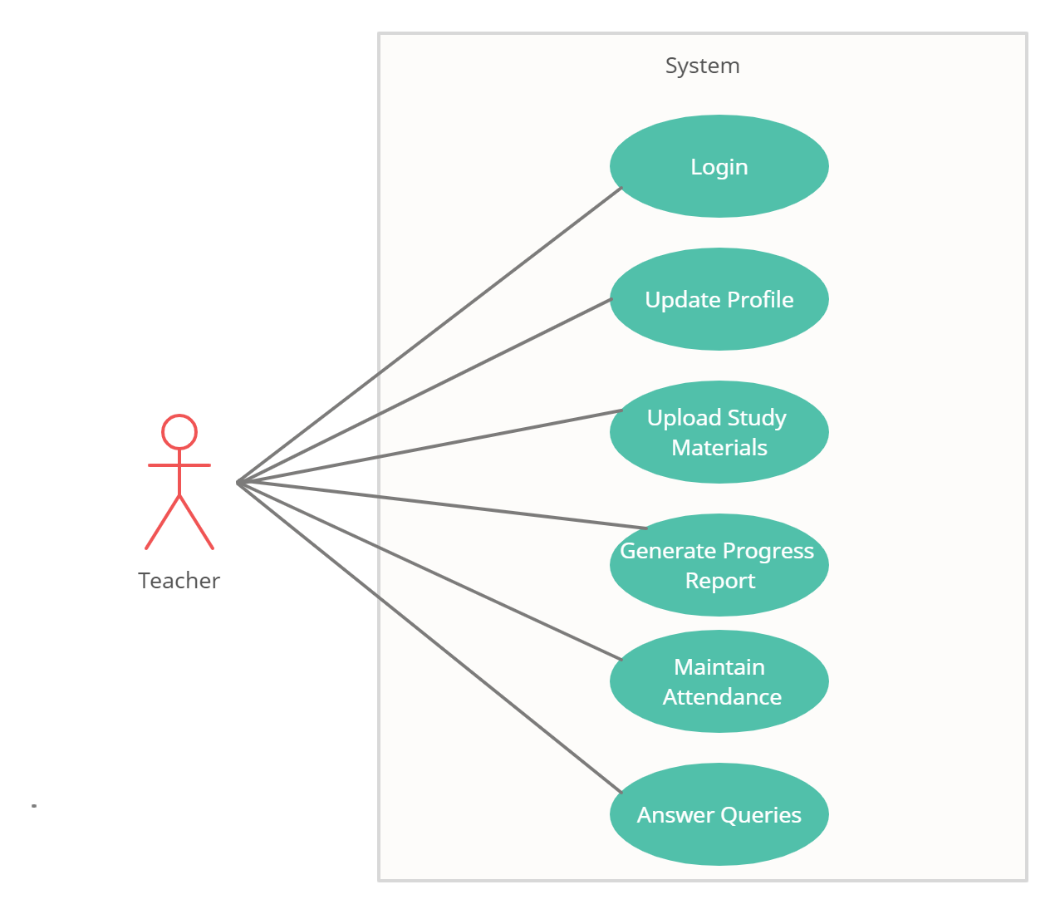

Fig. Use-Case Diagram for Teacher

**6. Database Design:**

**1] Admin table**

|  |  |  |  |  |  |
| --- | --- | --- | --- | --- | --- |
| **Field** | **Type** | **Null** | **Key** | **Default** | **Description** |
| **admin_id** | **Integer** | **Not null** | **PK** | **AI** | **Admin id** |
| **admin_name** | **Varchar(100)** | **Not null** |  |  | **Admin full name** |
| **user_id** | **Integer** | **Not null** |  |  | **User id** |

**2] bloodbank table:**

|  |  |  |  |  |  |
| --- | --- | --- | --- | --- | --- |
| **Field** | **Type** | **Null** | **Key** | **Default** | **Description** |
| bloodbank_id | Integer | Not null | PK | AI | Unique bloodbank id |
| address | Varchar(255) |  |  |  | Address of bloodbank |
| bloodbank_name | Varchar(255) | Not null |  |  | Name of the bloodbank |
| City | Varchar(50) | Not null |  |  | City |
| contact_number | Varchar(20) | Not null |  |  | Phone Number bloodbank |
| Email | Varchar(50) | Not null |  |  | email no of blood) |
| licence_no | Varchar(50) | Not null |  |  | Licence no |
| website | Varchar(100) | Not null |  |  | Web site url |
| User_id | int | Not null |  |  | User id |

**3] bloodstock table**

|  |  |  |  |  |  |
| --- | --- | --- | --- | --- | --- |
| **Field** | **Type** | **Null** | **Key** | **Default** | **Description** |
| Bloodstock_id | Integer | Not null | PK | AI | Blood stock |
| availability | Integer | Not null | FK |  | Availability status |
| bloodbank_id | Varchar(50) | Not null |  |  | Unique blood bank id |
| bloodcomponent | Varchar(50) | Not null |  |  | Types of blood component |
| blood group | Varchar(10) | Not null |  |  | Blood group |
| quantity | Int | Not null |  |  | Quanity of stock |

**4] donor table**

|  |  |  |  |  |  |
| --- | --- | --- | --- | --- | --- |
| **Field** | **Type** | **Null** | **Key** | **Default** | **Description** |
| Donor_id | Int | Not null | PK |  | Donor id |
| Address | Varchar(255) | Not null |  |  | Donor address |
| age | Integer | Not null |  |  | Donor age |
| Blood_group | Varchar(10) | Not null |  |  | Blood group |
| City | Varchar(50) | Not null |  |  | Donor’s city |
| Contact_number | Varchar(20) | Not null |  |  | Donor contact number |
| Donor_name | Varchar(100) | Not null |  |  | Full name of donor |
| Email | Varchar(50) | Not null |  |  | Email id |
| gender | Varchar(50) | Not null |  |  | Gender of donor |
| User_id | Int | Not null |  |  | User id |

**5] donorrequest table**

|  |  |  |  |  |  |
| --- | --- | --- | --- | --- | --- |
| **Field** | **Type** | **Null** | **Key** | **Default** | **Description** |
| request_id | Integer | Not null | PK | AI | Request ID |
| bloodbank_id | Integer | Not null |  |  | Bloodbank ID |
| bloodgroup | Varchar(10) | Not null | FK |  | Blood group |
| contact_number | Varchar(20) | Not null |  |  | Contact number of donor |
| donor_id | Integer | Not null |  |  | Donor ID |
| donor_name | Varchar(100) | Not null |  |  | Donor’s name |
| status | Varchar(50) | Not null |  |  | Availability Status |

**6] hospital table**

|  |  |  |  |  |  |
| --- | --- | --- | --- | --- | --- |
| **Field** | **Type** | **Null** | **Key** | **Default** | **Description** |
| hospital_id | Integer | Not Null | PK | AI | Hospital Id |
| address | Varchar(255) | Not null |  |  | Hospital address |
| city | Varchar(50) | Not null |  |  | City |
| contact_number | Varchar(20) | Not null |  |  | Hospital contact number |
| Email | Varchar(50) | Not null |  |  | Email |
| hospital_name | Varchar(100) | Not null |  |  | Hospital name |
| licence_no | Varchar(50) | Not null |  |  | Registration number |
| website | Varchar(100) | Not null |  |  | Varchar |
| user_id | Integer | Not null |  |  | User id |

**7] hospital request**

|  |  |  |  |  |  |
| --- | --- | --- | --- | --- | --- |
| **Field** | **Type** | **Null** | **Key** | **Default** | **Description** |
| Hospital_request_id | Integer | Not null | PK | AI | Hospital’s request Id |
| Bloodbank_id | Integer | Not null |  |  | Bloodbank Id |
| Blood_component | Varchar(50) | Not null |  |  | Component of blood |
| Hospital_id | Integer | Not null |  |  | Hospital Id |
| Hospital_name | Varchar(100) | Not null |  |  | Hospital name |
| Hospital_phone_number | Varchar(20) | Not null |  |  | Hospital contact number |
| Quantity | Integer | Not null |  |  | Requested quantity |
| Request_date | Datetime | Not null |  |  | Date of request |
| Request_status | Varchar(50) | Not null |  |  | Status of request |
| Patient_id | Integer | Not null |  |  | Patient Id |

**8] login table**

|  |  |  |  |  |  |
| --- | --- | --- | --- | --- | --- |
| **Field** | **Type** | **Null** | **Key** | **Default** | **Description** |
| User_id | Integer | Not null | PK | AI | User id |
| Member_type | Varchar(50) | Not null |  |  | Type of account |
| Password | Varchar(50) | Not null |  |  | Password for login |
| User_name | Varchar (50) | Not null |  |  | Username for login |

**9] patient table**

|  |  |  |  |  |  |
| --- | --- | --- | --- | --- | --- |
| **Field** | **Type** | **Null** | **Key** | **Default** | **Description** |
| Patient_id | Integer | Not null | PK | AI | Patient id |
| Aadharnumber | Varchar(50) | Not null |  |  | Patient’s aadhar number |
| City | Varchar(50) | Not null |  |  | City |
| Gender | Varchar(50) | Not null |  |  | Patient’s gender |
| Age | Integer | Not null |  |  | Patient’s age |
| Bloodgrp | Varchar(10) | Not null |  |  | Patient’s blood group |
| Patient_fname | Varchar(50) | Not null |  |  | Patient first name |
| Patient_lname | Varchar(50) | Not null |  |  | Patient last name |
| Phone_number | Varchar(20) | Not null |  |  | Patient phone number |
| Registration_date | date | Not null |  |  | Registration date |
| Hospital_id | Integer | Not null |  |  | Hospital id |

## 7. ER-Diagram:

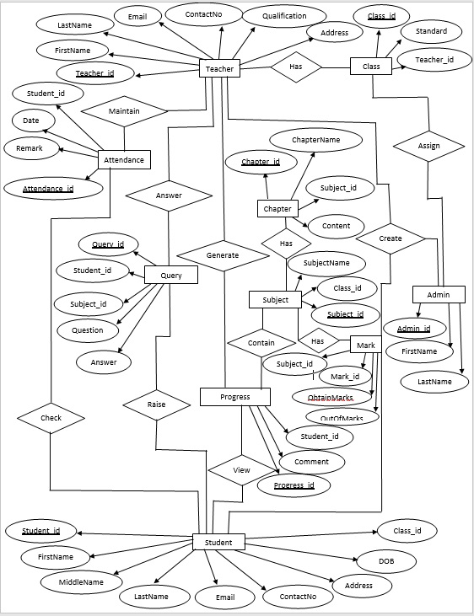

**E-R diagram shows database of Paperless School Management System**

**8. Snapshots:**

**8.1 Home Page:**

Following snapshot shows the Home page for Paperless School Management System



This page contains following controls

* Home
* Contact
* About
* Login Button

**8.2 Contact Page**

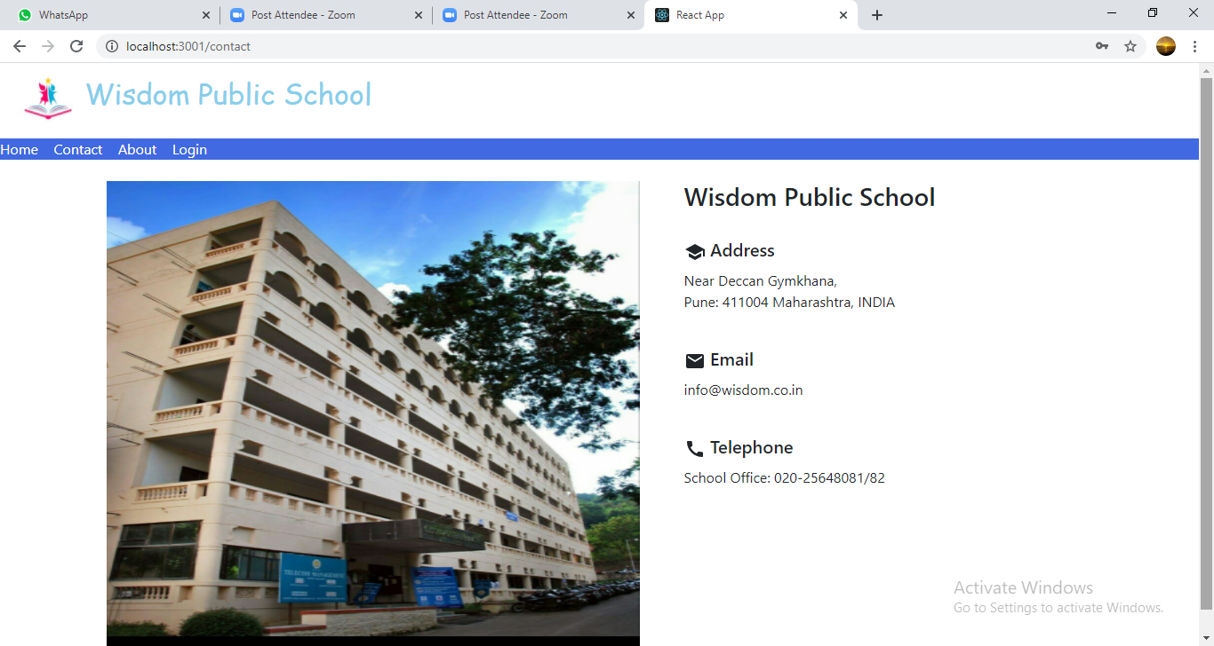

**8.3 About Page**

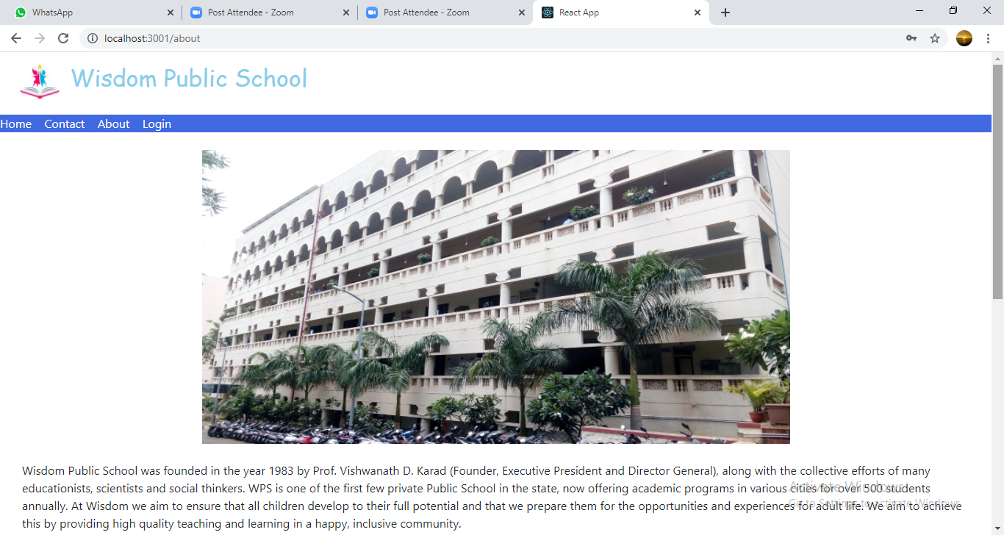

**8.4 Login Page**

Following snapshot shows the Login page for Paperless School Management System

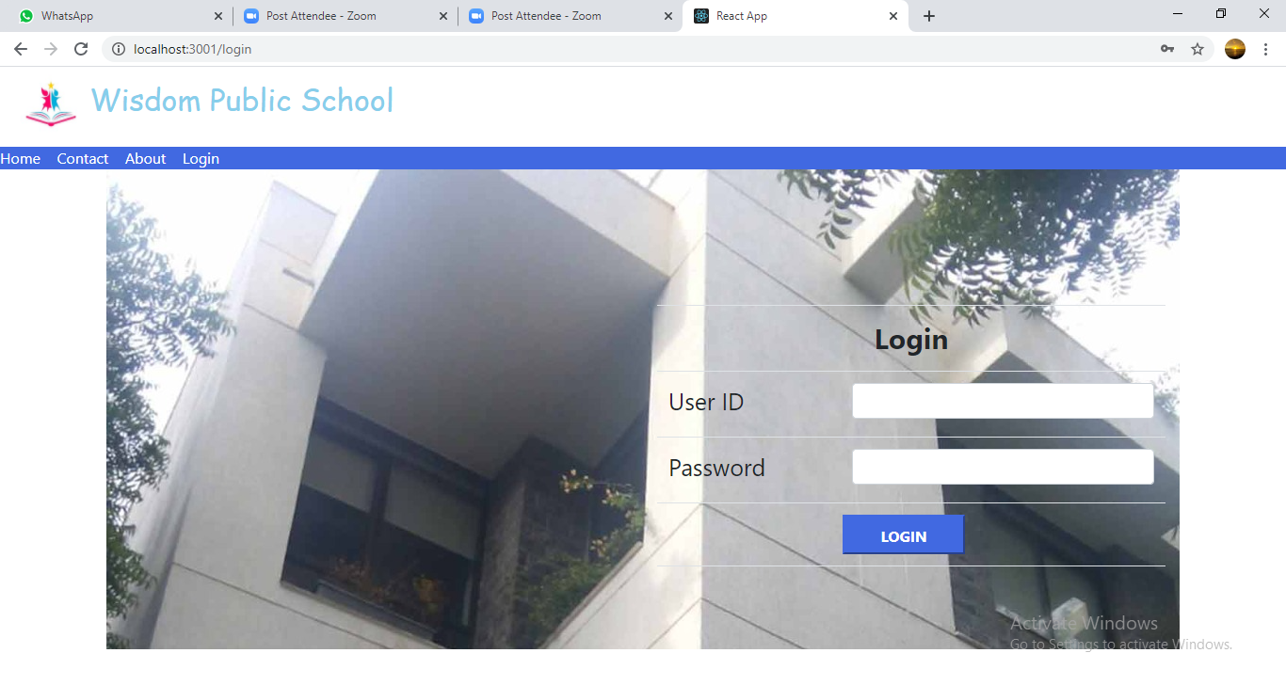

**8.5 Admin Home Page**

**8.5.1 Student Registration Page**

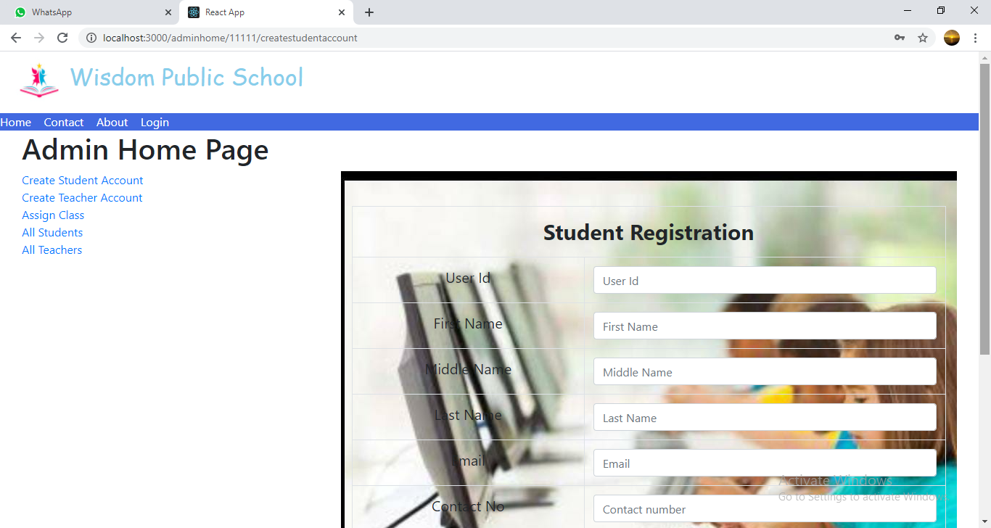

**8.5.2 Teacher Registration Page**

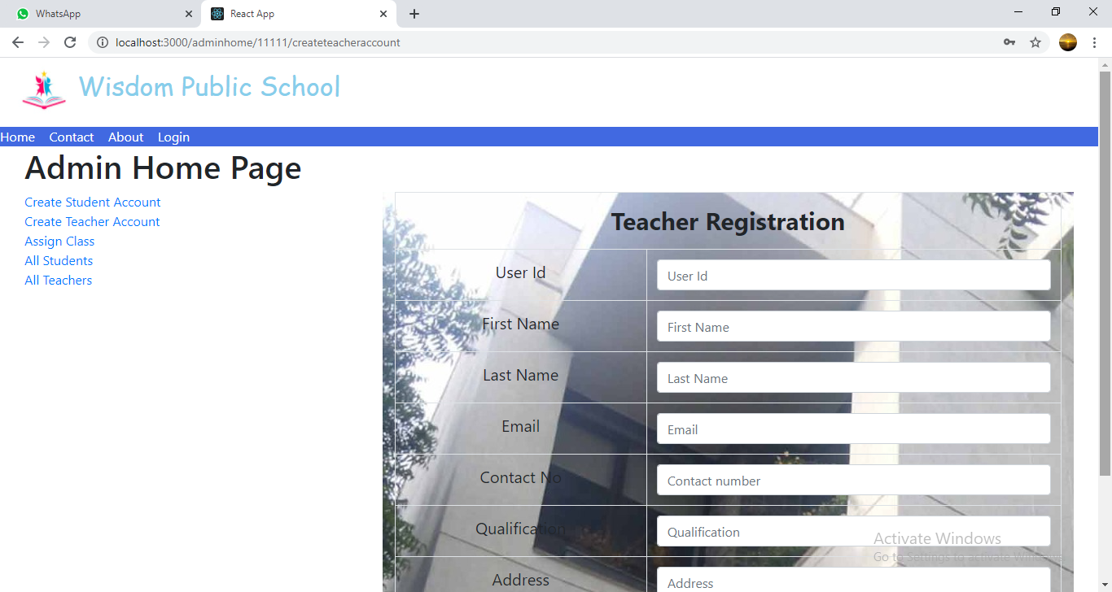

**8.5.3 Assign Class Page**

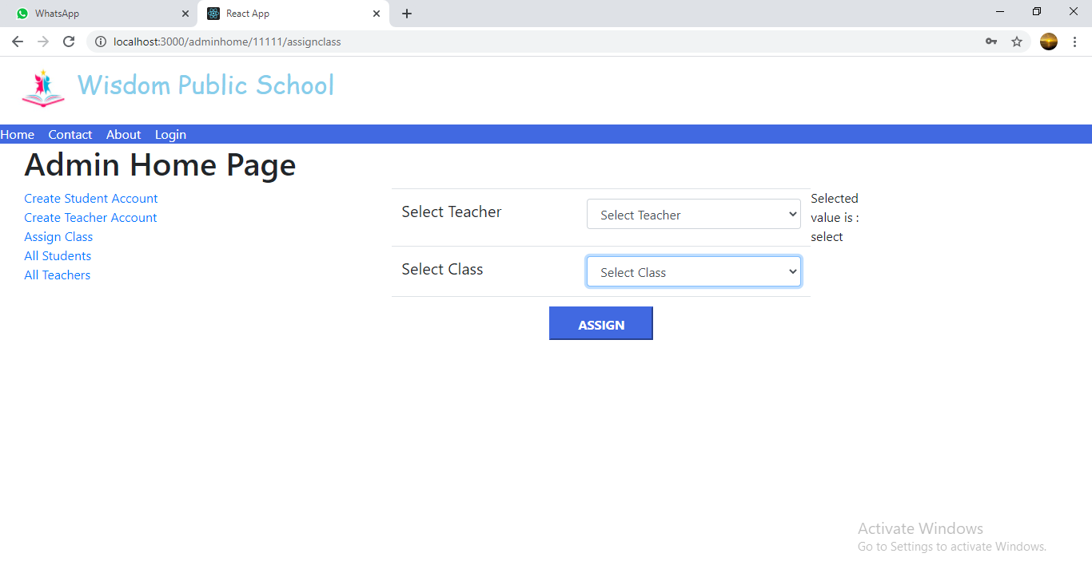

**8.5.4 All Students List**

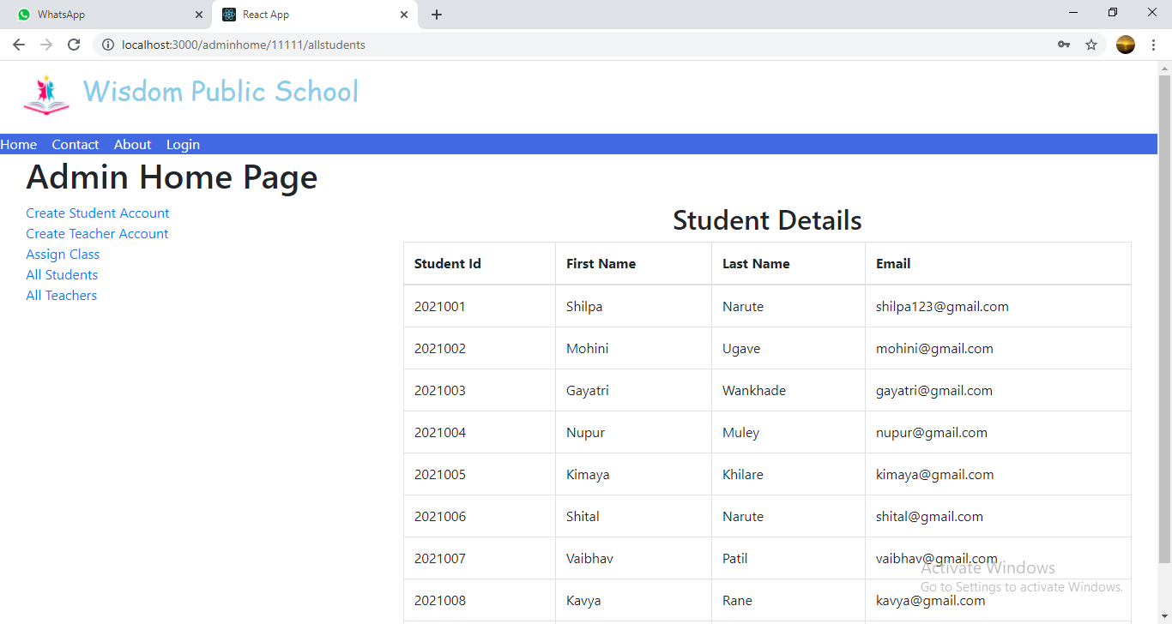

**8.5.5 All Teachers List**

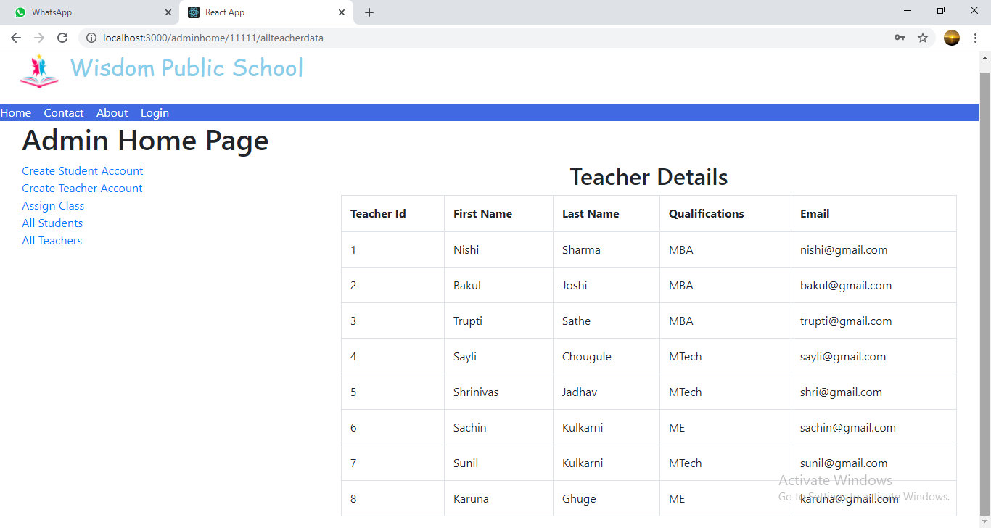

**8.6 Teacher Home Page**

**8.6.1 Upload Study Material Page**

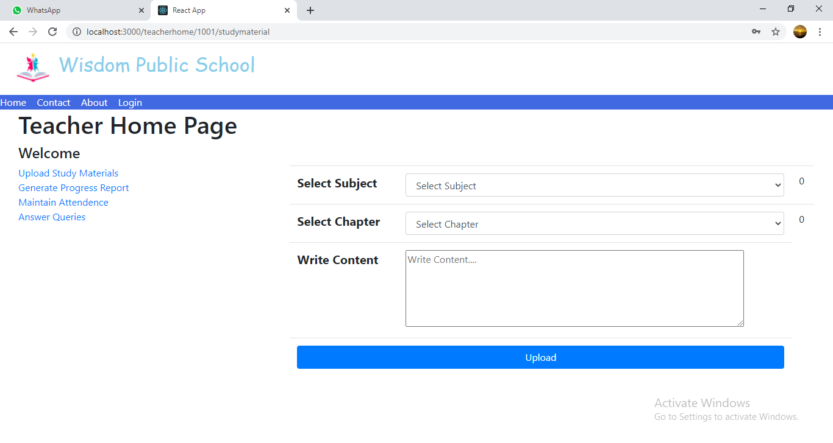

**8.6.2 Generate Progress Report Page**

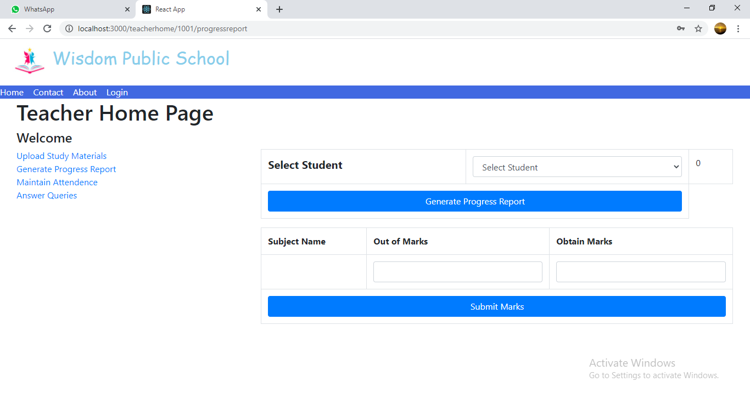

**8.6.3 Maintain Attendance Page**

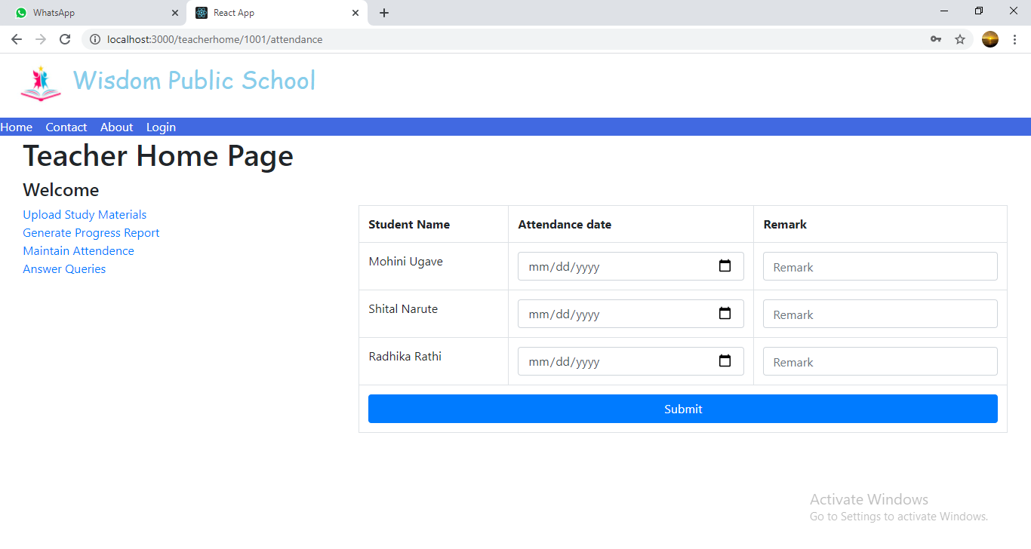

**8.6.4 Answer Queries Page**

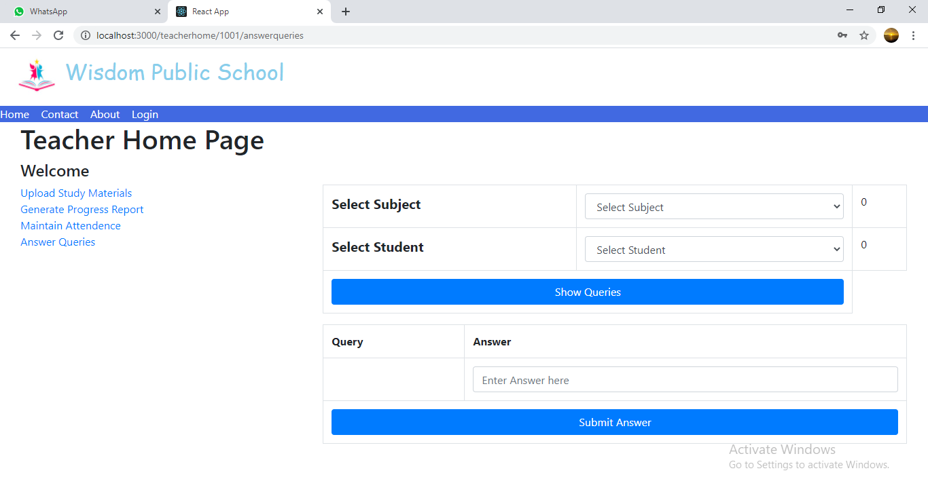

**8.7 Student Home Page**

**8.7.1 View Study Material Page**

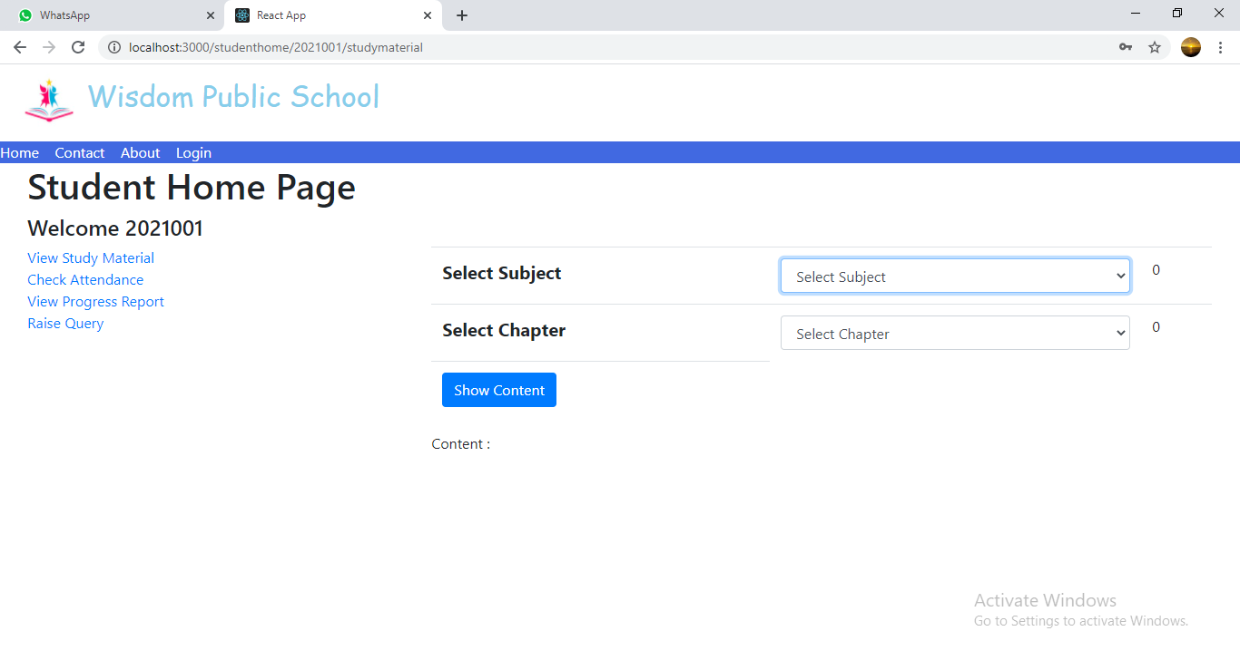

**8.7.2 Check Attendance Page**

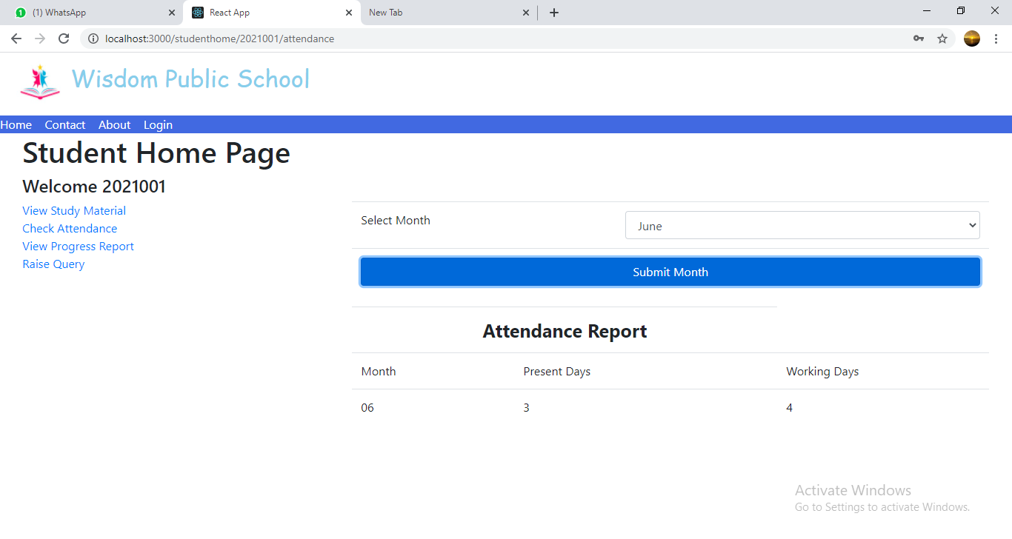

**8.7.3 View Progress Report Page**

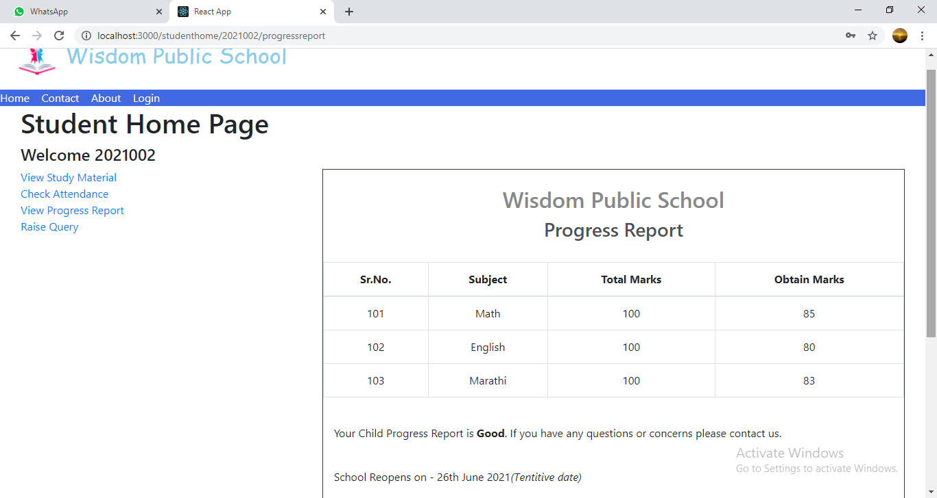

**8.7.4 Raise Query Page**

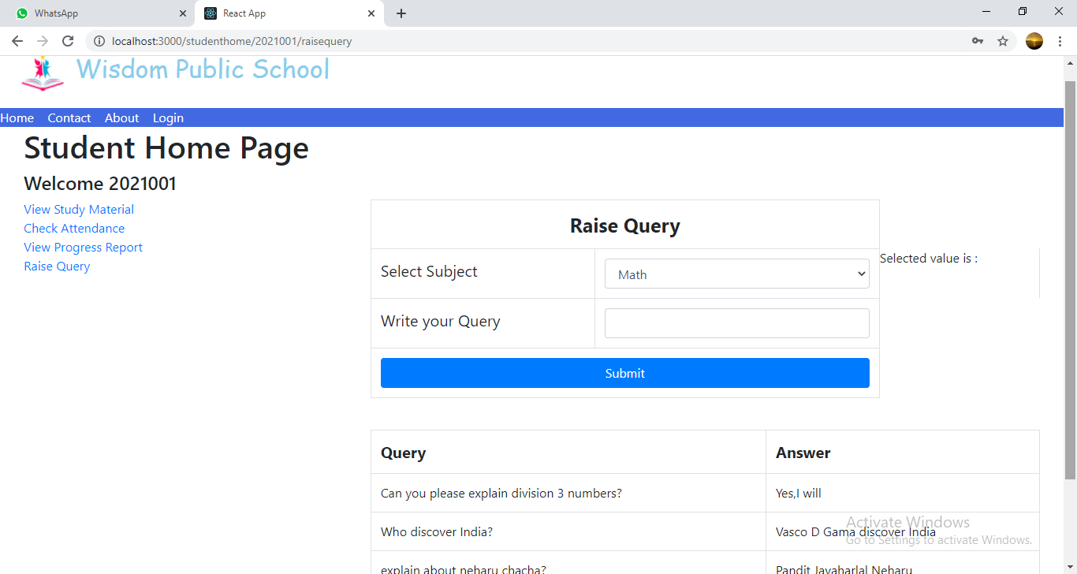

**9. CONCLUSION AND FUTURE SCOPE**

E-RaktDaan provides platform to facilitate hassle-free blood donation as well as supply of blood with those in need.

Our System provides a very user-friendly platform where Hospitals can put request for their patients and also the donors who want to donate blood can also have ease of access to information and easy access to blood banks by using online donation requests.

Our system is aimed efficient management of supply and demand of blood and its components.